Global Terrorism Analysis

Md.Amanatullah

We can see here that attacks slowly start to increase from 1970 until about 1993 where until 2003 we see a downward global trend in Terrorist incidents despite events like September 11, 2001. We can also see in this second graph that the number of bombings follows roughly the same trend, but that it has a sharper decline of occurrences in the early 90s.

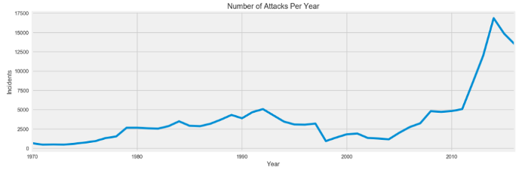

Global Terrorist Attack Incidents 1970–2016

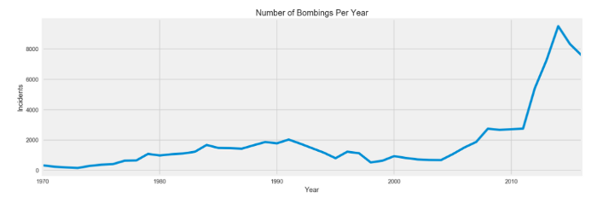

Global Bombing Numbers 1970–2016

Here it becomes very clear how the overall trend over attacks has changed over the years in different regions across the globe. In the 1970s we can see that most terrorist attacks occurred in Western Europe, followed by Latin and South America in the 1980s, but then there is an overall decline in the number of attacks between the mid-1990s and 2003. We can also see that come we experience the same jump in numbers and see that the Middle East and North Africa along with South Asia are the hardest hit by terrorist attacks. However, it is also important to note that while the amount by which overall trends increase it does appear that no matter the region the occurrence of terrorist attacks has risen.

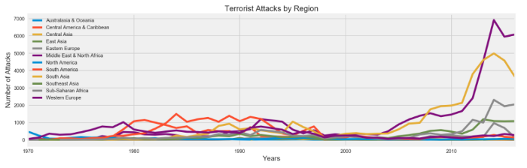

Terrorist Attacks by Region 1970–2016

Here we can see that in the past 47 years the overwhelming favored form of attack has been bombings with it being the choice of terrorists more than twice that of Armed Assaults. However, it should be noted that if there is a distinction between when these two happen separately or together I was unable to find such a data clarify so these numbers may be askew as events like the Mumbai Hotel and Bataclan attacks both involved both bombs and armed assaults. Interestingly, hijacking is in last despite its prevalence in the 1970s and 1980s.

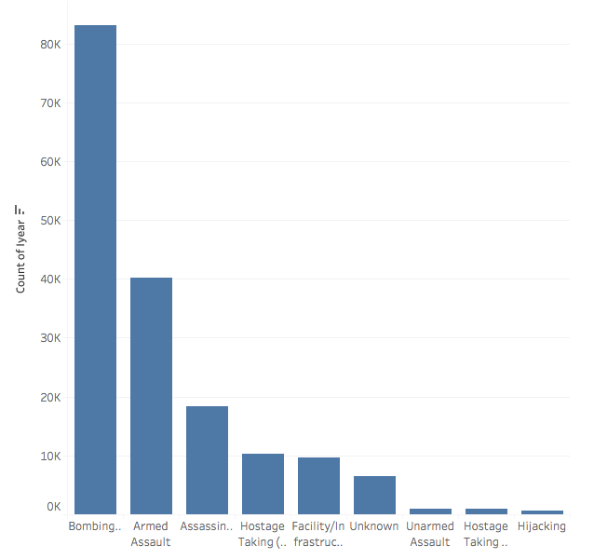

Type of Terror Attacks

Below, we see a tableau generated chart of the type of targets that are “hit the hardest” by number of injured and by numbers killed with the size of the circle being the number of occurrences. We can see overwhelmingly that the most frequent target is civilians who as a result also suffer the most at the hands of terrorists. However, this graph can be misleading because single events like 9/11, the 1993 WTC bombings, and Bishopsgate can skew that number as all three registered either high numbers of killed, injured or both. It should also be noted that this is a prime example of when you should better organize your data as there are several points in this graph that could be combined. Such as Civilian could encompass Village, Market, Vehicle, Bus, and of course Civilians while a single Military class could include Military Unit, Soldiers, Checkpoint, Patrol, Convoy, Officers, Unit, and Police Station.

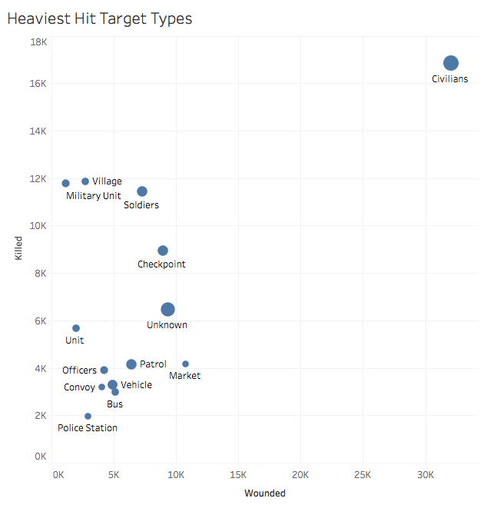

As terrorist actions are often a reaction to an action taken by the targets government or country I next wanted to see if there were any similarities in the trends in number of incidents between countries that have historically not gotten along well (to put it nicely).

The first comparison is the United Kingdom and Ireland where we can see from chart below that the United Kingdom has taken the brunt of all the violence. The peaks largely related to the conflict between these two countries are those between 1970 and the end of the 1990s which encompasses the entire period known as the “[The Troubles](https://en.wikipedia.org/wiki/The_Troubles)” where over 3,500 people died and more than 47,500 were injured. An important note here is that though it appears a large portion of the attacks came in the United Kingdom most the incidents did not occur in mainland Britain, but in Northern Ireland so if you were to display the entire Eire (Ireland and Northern Ireland) vs the UK I imagine the numbers would be different.

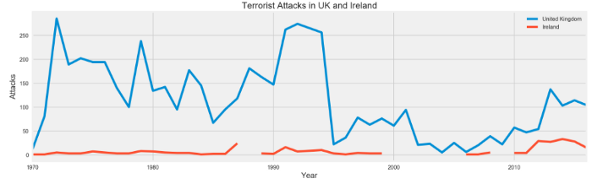

UK vs Ireland Incidents

Next, we see two countries that since their independence from the British have had a tumultuous history. However, we can see that except for one jump in the mid-1990s the number of terrorist incidents tends to stay below 500 each year and most are in India. However, this all begins to change in 2008 with the Mumbai Terror attacks. From that point, onwards Pakistan has taken overwhelmingly had more terrorist incidents over India, but it appears that in the last year or two that number has begun to dramatically reduce itself. However, India’s number since 2008 have sharply risen since the attack and ever since that appears to be a slow, but steady increase in attacks. In fact, if you zoom in on the very end of the graph you can see that India surpasses Pakistan in number of incidents.

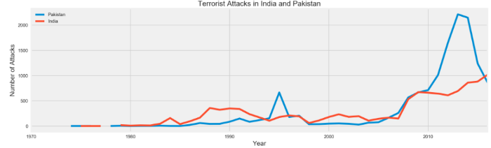

India vs Pakistan

Two other countries we have seen lock heads over the 46 years are of course the United States and Russia. While their wars between them were either proxy ways or cold war’s (i.e. sanctions, espionage, etc.) it never reached a full-scale war that would have likely encompassed the globe. However, we can see here that while the United States has experienced some high-profile terrorist attacks by groups like The Weather underground, Timothy McVeigh, the Unabomber, Al-Qaeda, ISIS, and the Tsarnaev brothers it has largely experienced a great deal fewer number of attacks than Russia. This is largely due to the considerably fewer amounts of areas in the US that are as volatile as certain regions of Russia and the Former Soviet Union like Dagestan, Chechnya, or the Ukrainian/Russian border as well as Russia’s conflict with Georgia. Both have suffered, but clearly due to both Russia’s size and violent involvement amongst itself and neighboring countries it has suffered the most at the hands of terrorists.

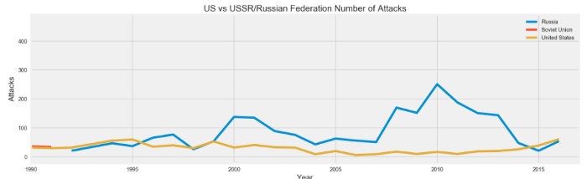

United States vs Russian Federation/USSR

On a happier, and a large portion of my focus for this individual project, the situation in South Africa has significantly improved since 1994 with the country’s first free elections to appoint Nelson Mandela as President and unofficially end Apartheid. While, the official end of Apartheid is 1991 with the release of Mandela from prison the elections would not be held until three years later. In fact, we can see from the graph below that between 1991 and 1994 was among the most violent times in South Africa as Afrikaner nationalists took to more violent means to, unsuccessfully, prevent the elections in 1994 which would of course provoke actions from Black South Africans to strike back. Fortunately, we can see the years we have data for following the elections the number of incidents dropped significantly. Sadly, it does appear that the data has begun to disappear after 2000 which for anyone who knows South African history and politics includes the Presidencies of Mbeki and Zuma who have both been less than transparent about the state of the country.

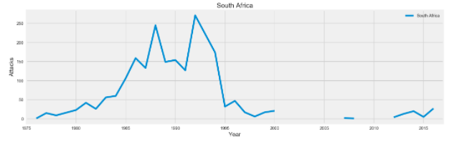

While it does appear that the numbers have gone down significantly since 1994 this graph shows us two things that an individual must do his/her best to obtain and/or manage when dealing with data like this for all data. Which is to gain as much knowledge surrounding your data outside of the numbers to obtain some context and to be able to understand or extrapolate from the data you do have to generate possible numbers for the data we don’t.

12